Successful Family Living
ALL Parents and Caregivers are welcome! No required fees!

Parenting Class designed for families seeking to get to the core of family matters. This course helps participants identify the current family structure and systems at work within their family. Tools will be supplied throughout the course to lay the foundation needed to support a more successful family life plan.

Photo identification required at enrollment and during each session attended for all participants seeking a certificate of completion. Attendance, on-time arrival & participation in all 4 Sessions is required to obtain a course completion certificate from WPC.

Session 1: What is a Family?

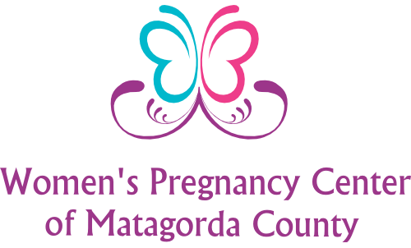

Location: 3107 Ave. F., Bay City, TX 77414
Email: director@baycitywpc.org
Class Reservations (979) 245-9900

Office Hours:
Mon-Thursday
9 am – 2 pm

Session 2: Successful Family
Session 3: Creating Kindness

Session 4: Modeling Courage

Daytime Sessions available at 11 a.m.
Session 1 July 18th
Session 2 July 25th
Session 3 August 1st
Session 4 August 8th

Evening Sessions available at 5:30 p.m.
Session 1 August 22nd
Session 2 August 29th
Session 3 September 5th
Session 4 September 12th

Build your own schedule to complete sessions 1-4.
Avoid attendance duplications of the same session number.

